**MAULANA AZAD**

**NATIONAL INSTITUTE OF TECHNOLOGY**

**BHOPAL INDIA, 462003**







**DEPARTMENT OF COMPUTER SCIENCE & ENGINEERING**

Topic - Using EEG to detect student’s confusion in online classes

**Minor Project Report**

**Semester 5**

**Submitted by:**

| Manali Agrawal | 191112003 |
| --- | --- |
| Ankush Sharma | 191112052 |
| Chelsi Garg | 191112062 |
|  |  |

**Under the Guidance of**

Dr. Mitul Kumar Ahirwal

## DEPARTMENT OF COMPUTER SCIENCE AND ENGINEERING

**Session: 2021-2022**

**MAULANA AZAD**

**NATIONAL INSTITUTE OF TECHNOLOGY**

**BHOPAL INDIA, 462003**







**DEPARTMENT OF COMPUTER SCIENCE & ENGINEERING**

# CERTIFICATE

This is to certify that the project report carried out on “Using EEG to detect student’s confusion in online classes” by the 3rd year students:

| Manali Agrawal | 191112003 |
| --- | --- |
| Ankush Sharma | 191112052 |
| Chelsi Garg | 191112062 |

## Have successfully completed their project in partial fulfilment of their Degree in Bachelor of Technology in Computer Science and Engineering.



**Dr. Mitul Kumar Ahirwal**

**(Minor Project Mentor)**

**ii**

# DECLARATION

## We, hereby declare that the following report which is being presented in the Minor Project Documentation Entitled as “Using EEG to detect student’s confusion in online classes” is an authentic documentation of our own original work and to best of our knowledge. The following project and its report, in part or whole, has not been presented or submitted by us for any purpose in any other institute or organization. Any contribution made to the research by others, with whom we have worked at Maulana Azad National Institute of Technology, Bhopal or elsewhere, is explicitly acknowledged in the report.

| Manali Agrawal | 191112003 |
| --- | --- |
| Ankush Sharma | 191112052 |
| Chelsi Garg | 191112062 |

**iii**

# ACKNOWLEDGEMENT

## With due respect, we express our deep sense of gratitude to our respected guide and coordinator Dr. Mitul Kumar Ahirwal, for his valuable help and guidance. We are thankful for the encouragement that he has given us in completing this project successfully.

## It is imperative for us to mention the fact that the report of minor project could not have been accomplished without the periodic suggestions and advice of our project guide Dr. Mitul Kumar Ahirwal and project coordinators Dr. Dhirendra Pratap Singh and Dr. Jaytrilok Choudhary.

## We are also grateful to our respected director Dr. N. S. Raghuwanshi for permitting us to utilize all the necessary facilities of the college.

## We are also thankful to all the other faculty, staff members and laboratory attendants of our department for their kind cooperation and help. Last but certainly not the least; we would like to express our deep appreciation towards our family members and batch mates for providing the much needed support and encouragement.

**iv**

# ABSTRACT

# In recent years, there is an increasing trend for online learning and it is more likely to continue as mentioned in [1]. Unlike classroom education, immediate feedback from the students is quite difficult in online classes. So, in order to get feedback from them or we can say in order to detect their confusion level, a single-channel EEG headset sensor can be used. This sensor is good enough for detecting students’ mental states and simple enough to use at home with very little training. Its signals are collected from students watching educational video clips. We trained and tested classifiers to detect when the scholar is confused while watching the course material. The classifier shows a comparable performance to human observers observing body language and expressions in predicting students’ confusion. We found accuracy in our model for using EEG to distinguish when a student is confused or not. This project promises deployable EEG devices having the power to capture tutor relevant information.

**v**

**Table of Contents**

**CERTIFICATE** **ii**

**DECLARATION** **iii**

**ACKNOWLEDGEMENT** **iv**

**ABSTRACT** **v**

**1. Introduction...............................................................................................................................1**

**2. Literature review and survey...................................................................................................2**

**3. Gaps Identified..........................................................................................................................3**

**4. Proposed work and methodology……………………………………………………………4**

**4.1 Method used - CNN…………………………………………………………………5**

# LIST OF FIGURES

# 

Figure 1 :

Figure 2 :

Figure 3 :

Figure 4 :

Figure 5 :

# LIST OF TABLES

Table 1 :

Table 2 :

Table 3 :

Table 4 :

# 

# INTRODUCTION

From the year 2020, people’s lives have been drastically affected due to the pandemic. We aren’t only physically affected but our profession, lifestyle, mental health everything is affected & so is the case with students. They are left with no option other than taking online classes.

Online classes can serve many students simultaneously but it has some limitations as well. In offline education, the teacher can judge whether the student is able to grab everything by seeing his/her body language or expressions but the same thing is not possible in online classes. As a result, classes became less-interactive [2]. Also, there are not any problem solving discussions among the students leaving them confused in several topics.

Hence, during this project our aim is to detect student’s confusion level by using electroencephalography (EEG) input from a commercially available device as evidence of students’ mental states.

The recent availability of simple, low-cost, portable EEG monitoring devices now makes it possible to take the technology from the lab into institutions. The NeuroSky ``MindSet”, as an example, is an audio headset equipped with a single-channel EEG sensor. It measures the voltage between an electrode that rests on the forehead and electrodes in touch with the ear. Unlike the multi-channel electrode nets worn in labs, the sensor needs no gel or saline for recording and thus requires much less expertise to position [3]. Even with the restrictions of recording from only one sensor and working with untrained users, a previous study (NeuroSky,2009) found that the MindSet distinguished two fairly similar mental states (neutral and attentive) with 86% accuracy. MindSet has been used to detect reading difficulty and human emotional responses.

We propose that institutes provide EEG device for scholars. In return, they might get feedback on students' EEG brain activity or confusion level while students attend online classes. As a result, the teacher can get feedback from an entire class & hence can improve their teaching accordingly [4]. Thus, we are hopeful that our proposal is incorporated in institutes’ facilities which could enhance student’s learning.

# LITERATURE REVIEW AND SURVEY

According to the survey done in [1], it is found that no. of institutions who agreed upon ‘‘Online education is critical to the long-term strategy of my institution’’ are 65.5%. The institutions who are found most interested in online learning are for-profit institutions.

One question that arises here is that do all the institutions that support online education also include online as a component of their strategic plan? Is there a ‘‘gap’’ between those who support online education and those that have specifically included online within their strategic plan? It is mentioned in [1] that private for-profit institutions are the ones to suffer from this gap.

One-third academic leaders believe that online learning is not as effective as offline ones. So, our effort is to make online classes effective by introducing immediate feedback from students which will result in good interaction.

# GAPS IDENTIFIED

Confusion is an emotion which occurs frequently while learning, especially during tough topics. It can be fruitful as it gives a chance to have a deeper understanding of that topic. But, if the confusion is not resolved on time then it can be harmful to learning. Such harmful learning is quite common with digital learning environments where teachers can not monitor each and every student.

Several research papers have been developed for the above stated problem. One of those research papers is [5]. They found weak but above chance performance (around 60%) for using EEG to detect whether a student is confused or not.

In our model, we used 1-D CNN method to detect accuracy & have tried to improve the accuracy. The results for the same are shown below in the report.

# METHOD USED - CNN:

1. **Introduction**

**1.1 Convolutional Neural Networks (CNNs)** is similar to the neurons that are self optimize by learning.Each neuron receives an input then perform a operation like scaler product then a non-linear function.From input to the final output,the entire network will express a single perceptive score function i.e weight and the last layer will contains the loss functions associated with the classes[9].CNN has multiple layers which processes the data in grid like arrangement and then extracts important features. CNNs are majorly used in pattern recognition in images that make him different from ANNs.CNNs also uses convolutions to handle maths.A convolution is used in place of matrix multiplication.Also,ANN has a limitation that they tend to struggle with computational complexity which is required in computing image data.

CNNs algorithm’s main purpose is to get the data in simpler form without losing the features.This makes them great candidates for handling.CNN works by applying filters to the input data and are able to adjust the filters accordingly when training happens.Because filter can be updated to train CNN better so it remove the need for hand created filters that increases the flexibility in number of filters that we apply in data set.

**1.2 Overfitting** - When a network is unable to learn efficiently due to some reasons that is called overfitting[9].This reduces the complexity of our CNNs.Lower the parameters required to train, less likely the network will overfit - and performance of the model is improved.

1. **CNN architecture**

CNNs mainly focuses on the input that comprised of images. This helps it to set up in way that needs for dealing with the specific datatype.Major difference is that the neurons that are in the layers in the CNN has neurons organised in three dimensions that are height,width and depth.

**2.1 Basic architecture**

CNN consist of three types of layers: convolutional layer, pooling layer and dense or fully-connected layer. When these three layers are combined, a CNN architecture has been formed.

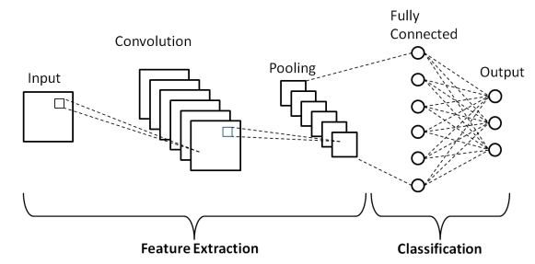

**2.2 Convolutional layer**

Convolutional layer extracts the features from the input via convolution operations.Convolutional layer helps to operate CNN.The layers parameters focus around the use of learnable kernels.Kernels are small in dimension, but spreads along the entire depth of he input. When data hits the convolutional layer, then the layer convolves each filter across the spatial dimensionality of the input to make a 2D activation map.[9]Convolutional layers also able to reduce the complexity of the model by optimizing the output.They optimizes by three parameters that are depth,stride and setting zero padding.

**Depth**

Depth of the output volume produced by the convolutional layers can be set accordingly by the number of neurons in the layer to the same region of input.Reducing the depth minimises the total number of neurons in the network, but it also reduce the pattern recognition capabilities of the model.

**Stride**

Stride is in which we set the depth around spatial dimensionality of input to place the receptive field.Stride is how far the filter moves in every step along the direction.

**Zero padding**

It is the simple process of padding the border of the input used to give further control to the dimensionality of the output volumes.we can calculate zero padding by using the below formula:

( (V − R) + 2Z) / ( S + 1)

Where V denotes input volume size.R denotes receptive field size,Z denotes amount of zero padding set and S denotes stride.

**2.3 Pooling layer**

Pooling layer merges some features to reduce the number of features.Pooling layer focuses to reduce the dimensionality of the representation, and to reduce the number of parameters and computational complexity of the model.Pooling layer operates over each activation map in the input, and scales its dimensionality using the MAX function.

**2.4 Dense or Fully connected layer**

Dense or fully connected layer classifies each pattern according to the previously extracted features.This layer contains neurons which are directly connected to the neurons in the two adjacent layers, without being connected to any layers within them[9].It also produces class scores from the activations, to be used for classification.We use ReLu between these layers to improve the performance.

# CONDITION IN WHICH DATA IS RECORDED

The dataset on which we worked is taken from [6].

The data contains EEG signals of college students while they were watching educational video clips. There are 2 types of video clips. First category of videos contain the topics with which students are quite familiar like introduction of basic algebra or geometry. Second category contains topics which could be confusing for them like Quantum Mechanics. There were a total 20 videos, 10 in each category. Each video was 2 minutes long. The two-minute clip was cut in the middle of a topic to make the videos more confusing [7].

Data is collected from 10 students. One student was removed because of missing data due to technical difficulty. An experiment with a student consisted of 10 rounds. 5 videos from each category were randomly picked & the sequence of their presentation was also randomized so that the student could not guess the video hence avoiding any kind of predefined confusion level. In each round, the student was first instructed to relax their mind for 30 seconds. Then, a video clip was shown to the student where he/she was instructed to try to learn as much as possible from the video. After each round, the student rated his/her confusion level on a scale of 1-7, where 1 corresponds to the least confusing and 7 corresponds to the most confusing. Also, there were three student observers watching the body-language of the student. Each observer rated the confusion level of the student in each round on a scale of 1-7.

The students wore a wireless single-channel MindSet that measured activity over the frontal lobe. The MindSet measures the voltage between an electrode resting on the forehead and two electrodes (one ground and one reference) each in-tuned with an ear. More accurately, the position on the forehead is Fp1 (somewhere between left eyebrow and the hairline), as defined by the International 10-20 system [7-8].

To collect the following signal streams, NeuroSky’s API was used:

1. The raw EEG signal, sampled at 512 Hz

2. An indicator of signal quality, reported at 1 Hz

3. MindSet’s proprietary “attention” and “meditation” signals are said to measure the user’s level of mental focus and calmness, reported at 1 Hz

4. A power spectrum, reported at 8 Hz, clustered into the standard named frequency bands: delta (1-3Hz), theta (4-7 Hz), alpha (8-11 Hz), beta (12-29 Hz), and gamma (30-100 Hz).

* Sampling Frequency: 512 Hz
* Number of Classes: 2
* Number of Samples in each classes: 49-not confused (Label 0), 51-confused(Label 1)
* Total Number of Samples: 100

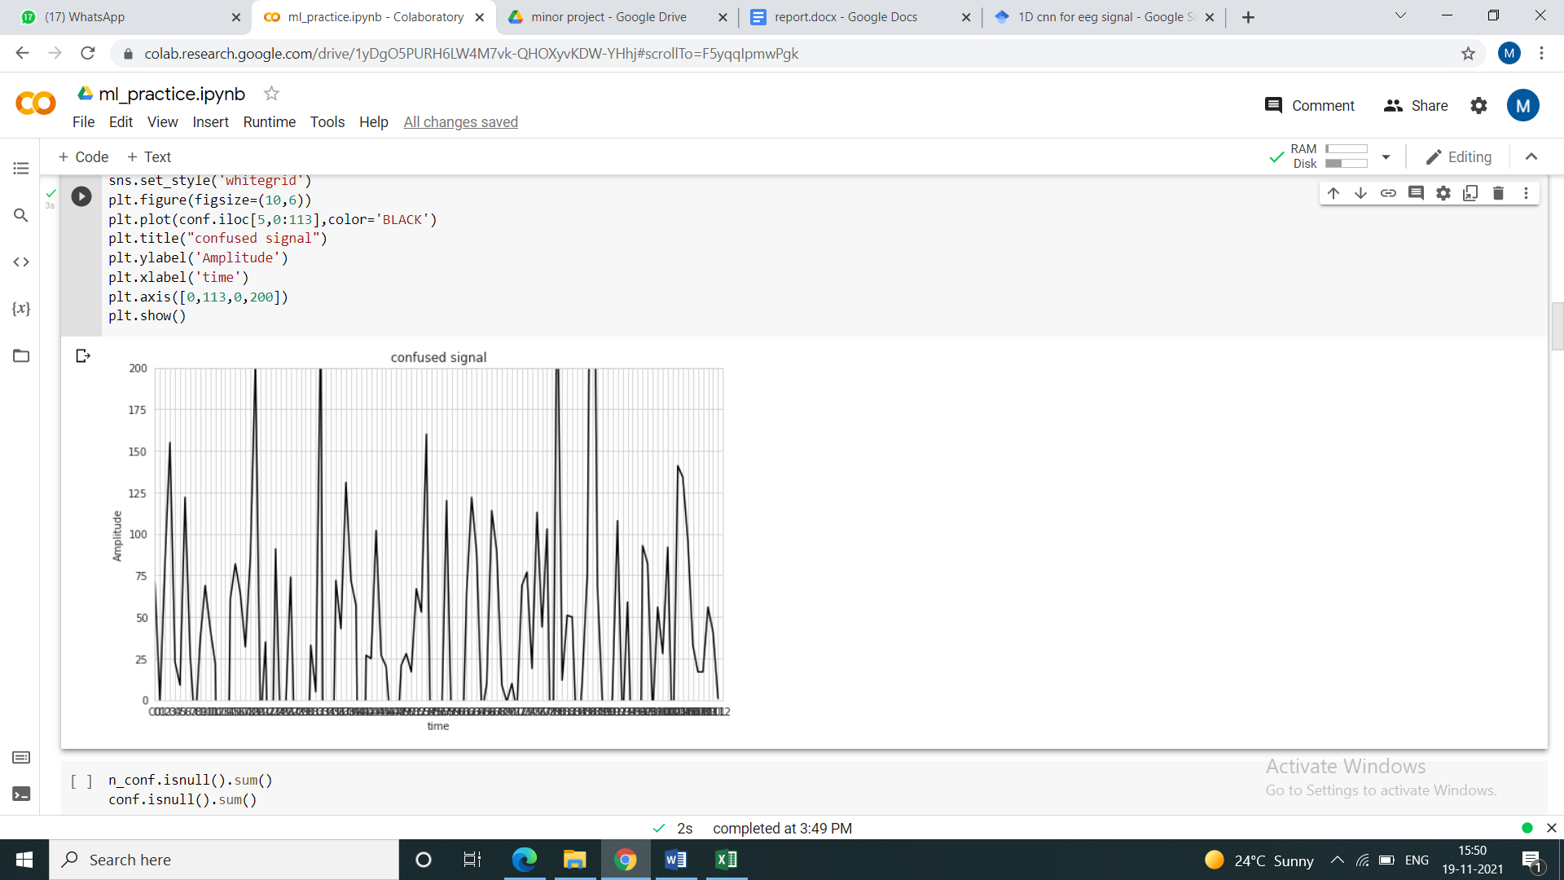

Figure2 - Confused EEG signal

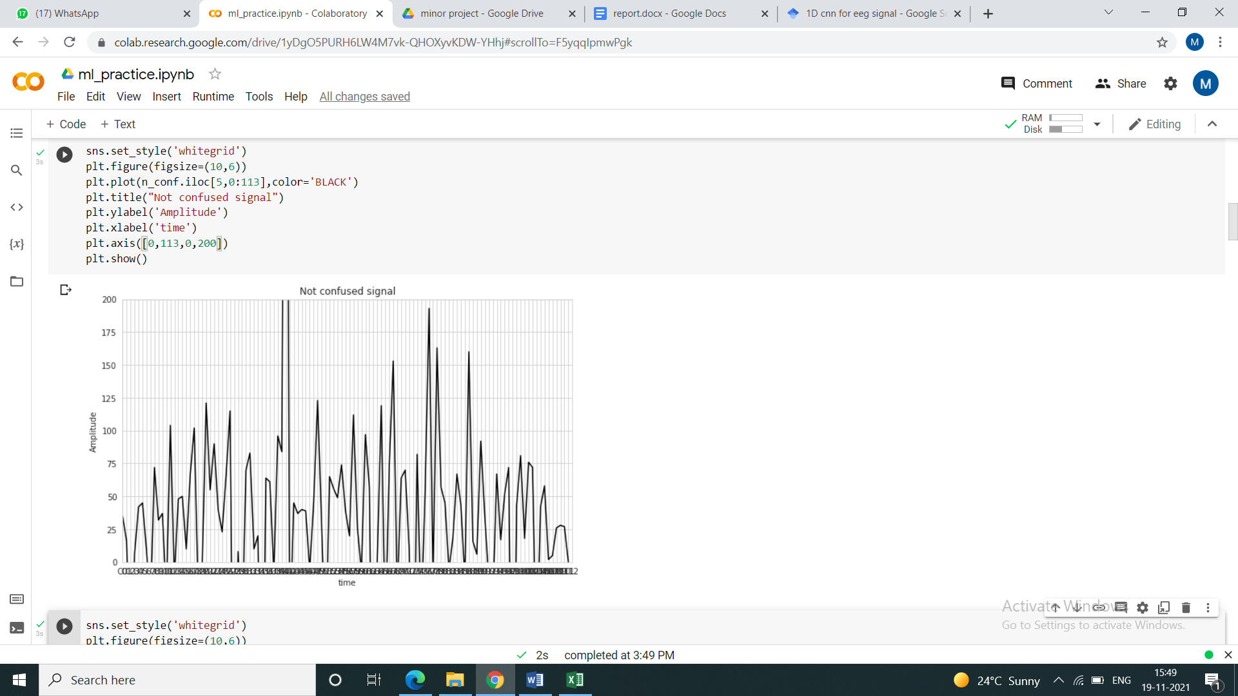

Figure3 - Not Confused EEG signal

# MODIFICATIONS IN DATABASE

The column named “raw” was considered and a new dataset was created using this column. This new dataset was then separated into two excel sheets namely confused and not_confused so that they can be used for designing 1D-CNN model for prediction of mental state of students as confused or not confused.

There were 51 samples for class “confused” and 49 samples for class “not confused”. Due to outliers some data points were removed which resulted in 46 samples for confused class and 44 samples in not confused class.

As the dataset is not balanced , resampling of data is done by which 500 samples of each class are generated.

**Training testing split ratio: 80:20**

Number of samples in train set: 800

Number of samples in test set: 200

# PROPOSED CNN ARCHITECTURE

##### 

##### Table 1 : Detailed parameters of the proposed 1D-CNN model

| Type of Layer | Output Shape | Other Parameters of each layer |
| --- | --- | --- |
| Conv1DBatch NormalizationMax Pooling 1DActivation | (109;80)(109;80)(36;80)(36;80) | Filters - 80,Kernel Size - 4, Pool Size – 3, Activation - Relu |
| Conv1DBatch NormalizationMax Pooling 1DActivation | (35;40)(35;40)(11;40)(11;40) | Filters - 40,Kernel Size - 2, Pool Size – 3, Activation - Relu |
| FlattenDenseDenseOutput Layer | (440)(5)(5)(2) | Units - 5, Activation – ReluUnits - 5, Activation – Relu Units - 2, Activation – SoftMax |

# RESULT

Maximum accuracy obtained after training the dataset using proposed 1D-CNN model was 98.5%. Confusion matrix was plotted as shown below

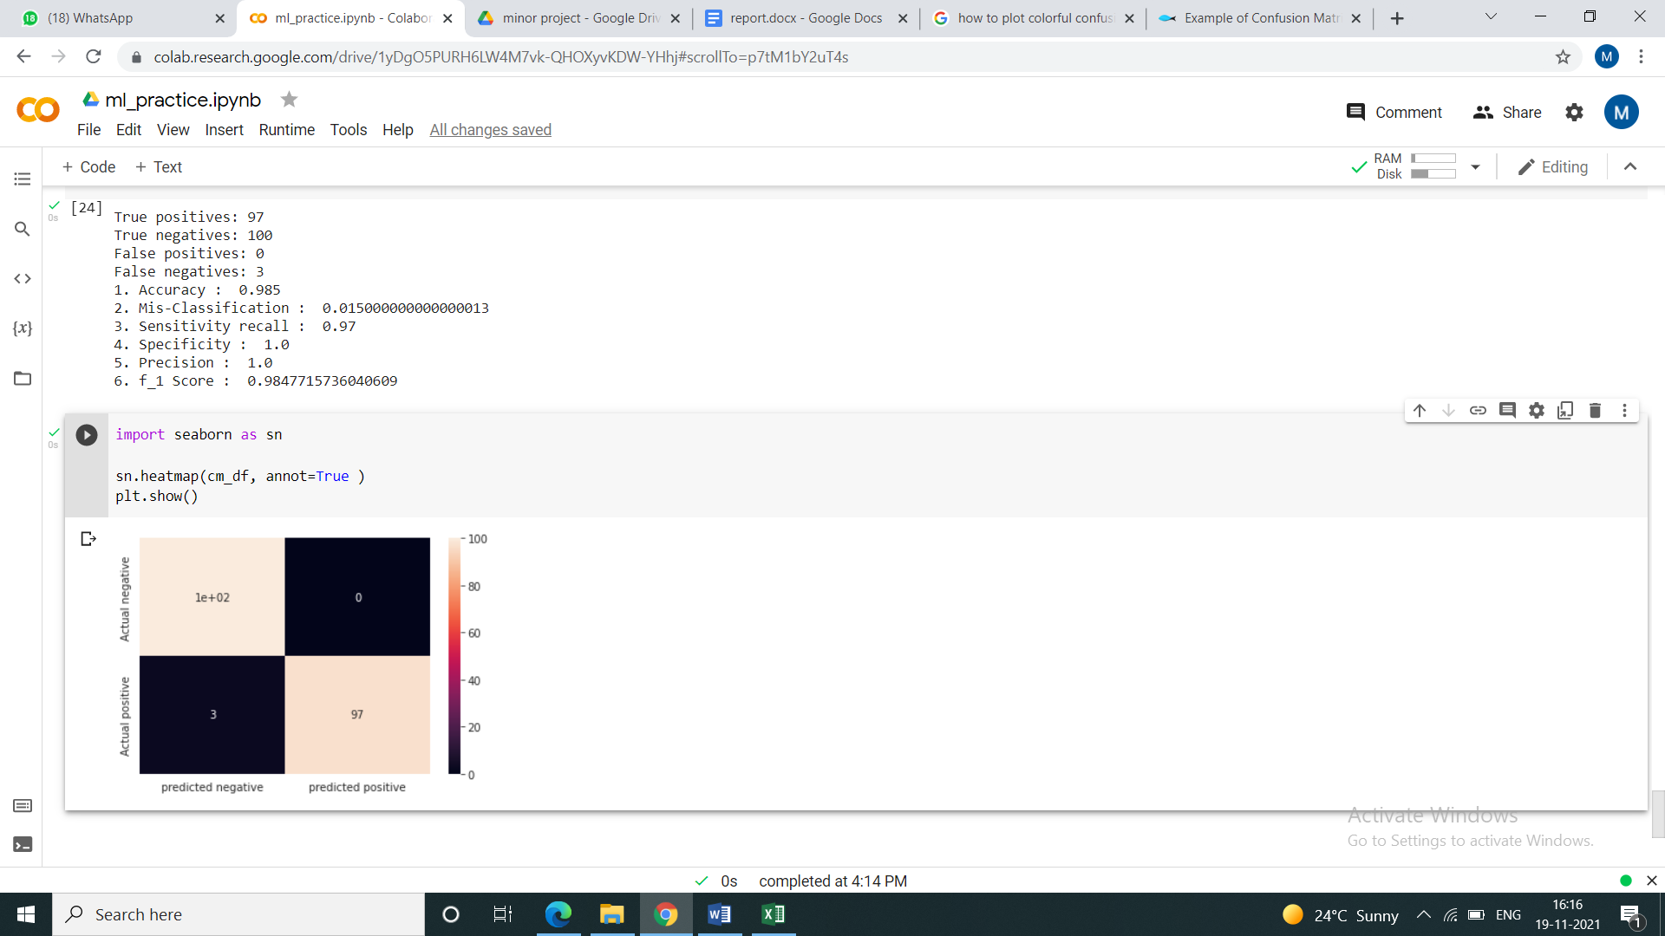

Figure4 - Confusion Matrix

|  | Predicted negative | Predicted positive |
| --- | --- | --- |
| Actual negative | 100 | 0 |
| Actual positive | 3 | 97 |

Table 2 - Confusion Matrix of Model

Various parameters were obtained using this confusion matrix to evaluate the model.

**Parameters are as follows :**

True positives: 97

True negatives: 100

False positives: 0

False negatives: 3

1. Accuracy : 0.985

2. Mis -Classification : 0.015000000000000013

3. Sensitivity recall : 0.97

4. Specificity : 1.0

5. Precision : 1.0

6. f_1 Score : 0.9847715736040609

**The 6 parameters are defined as following :**

(i) Accuracy(ACC): It is the ratio of correct predictions to total number of predictions. Accuracy is given by equation(1),

ACC = (TP+TN) **/** (TP+TN+FP+FN) , (1)

(ii) Mis-Classification(MC): It is the ratio of wrong predictions to total number of predictions. Mis-Classification is given by equation(2),

MC = 1 - ACC (2)

(iii) Sensitivity or Recall(RC) : It is the ratio of true positive to total number of predictions in actual positive. It is given by equation(2),

RC = TP **/** (FN+TP) , (3)

(iv) Specificity(SP) : It is the ratio of true negative to total number of predictions in actual negative. It is given by equation(4),

SP = TN **/** (TN+FP) , (4)

(v) Precision(PR) : It is the ratio of true positive to total number of predictions in predicted positive. It is given by equation(5),

PR = TP **/** (TP+FP) , (5)

(vi) F1 Score : It is the harmonic mean of PR and RC. It is given by equation(6),

F1 = 2*((PR*RC) **/** (PR+RC)) (6)

**Table 3 : Classification Report**

|  | **precision** | **recall** | **f1-score** | **support** |
| --- | --- | --- | --- | --- |
| **class 0** | 0.97 | 1.00 | 0.99 | 100 |
| **class 1** | 1.00 | 0.97 | 0.98 | 100 |
| **accuracy** | - | - | 0.98 | 200 |
| **macro avg** | 0.99 | 0.98 | 0.98 | 200 |
| **weighted avg** | 0.99 | 0.98 | 0.98 | 200 |

Accuracy and loss graphs are plotted for evaluating the result

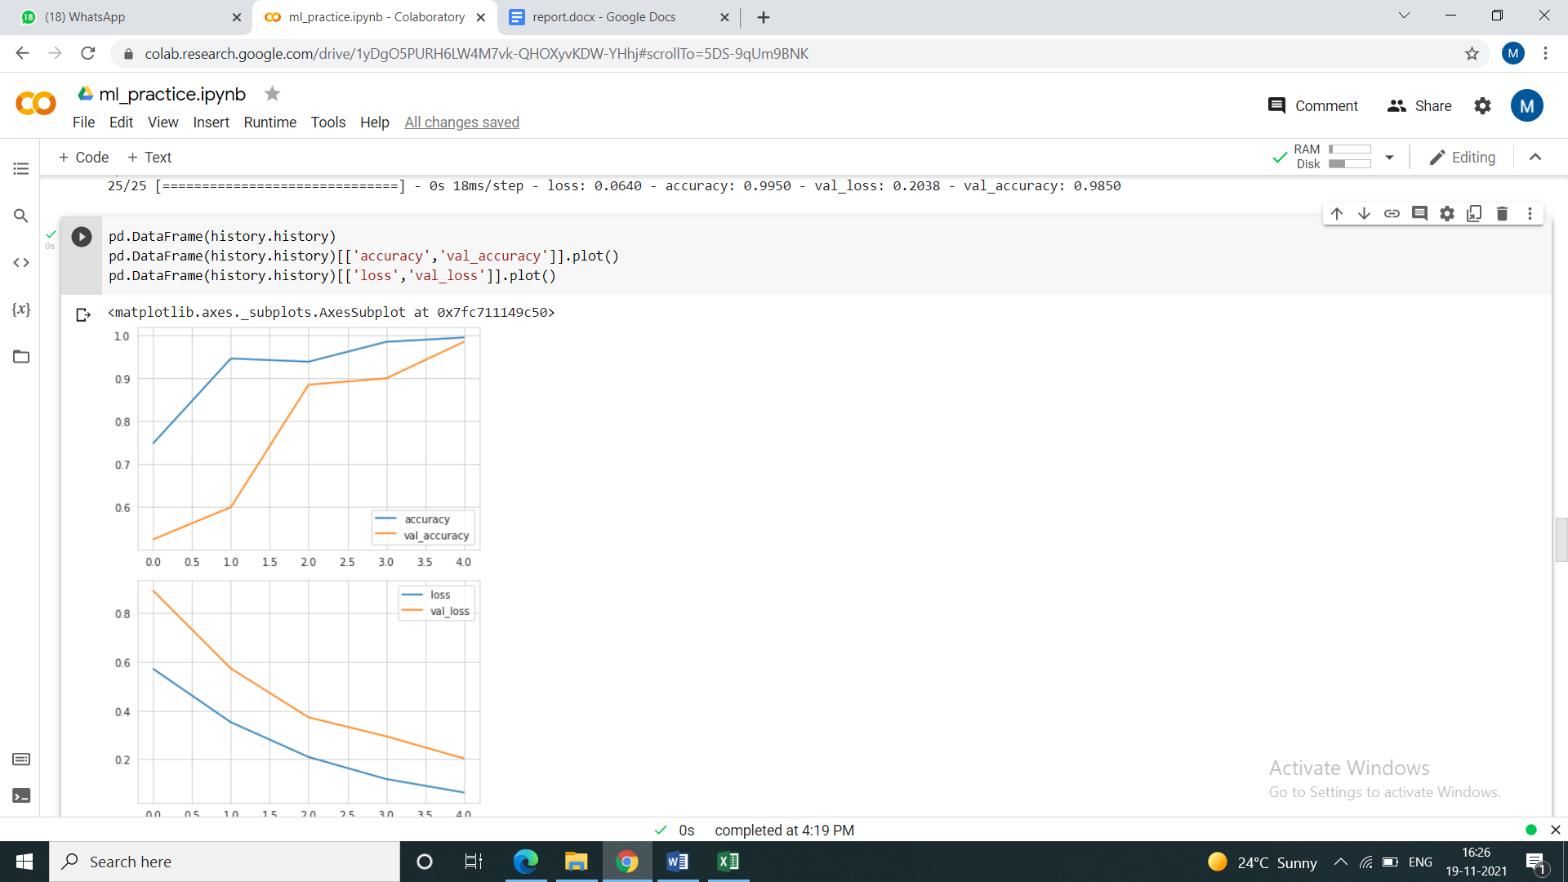

Figure 5- Training and validation accuracy of Model

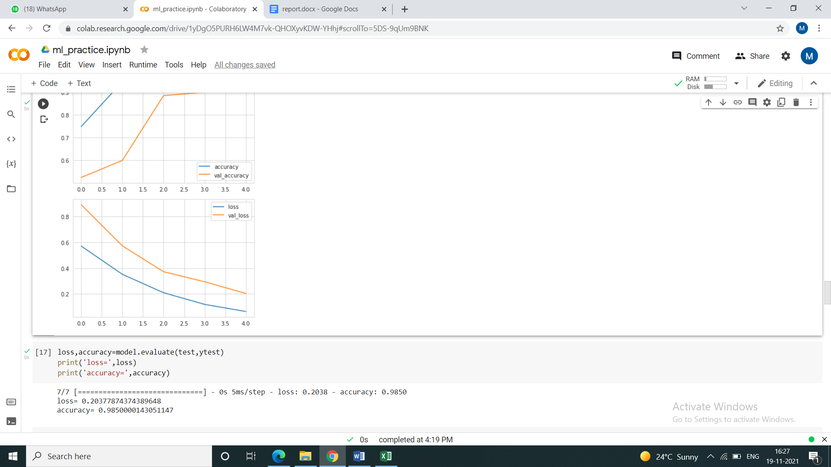

Figure 6- Training and validation loss of Model

# CONCLUSION

In this project, we worked on the dataset of students’ EEG brain activity while they learn from educational video clips. We trained and tested classifiers to detect when a student was confused. We used EEG signals to distinguish whether a student is confused. The classifier has comparable performance to human observers observing body language in predicting students’ confusion.

So, if the project is implemented on a bigger level like during online classes or the platforms which offer online courses, we are hopeful that this would help both teachers & students hence improving the quality of the content delivered.

One point which we want to highlight is not every student is willing to share their brain activity data due to some privacy concerns. In that case, they are advised to not use EEG.

# REFERENCES

* + - 1. Allen, I. Elaine, and Jeff Seaman. *Going the distance: Online education in the United States, 2011*. Sloan Consortium. PO Box 1238, Newburyport, MA 01950, 2011.
      2. Thompson, Gordon. "How can correspondence-based distance education be improved? A survey of attitudes of students who are not well disposed toward correspondence study." *Journal of Distance Education* 5.1 (1990): 53-65.
      3. Rebolledo-Mendez, Genaro, et al. "Assessing neurosky’s usability to detect attention levels in an assessment exercise." *International Conference on Human-Computer Interaction*. Springer, Berlin, Heidelberg, 2009.
      4. Chang, Kai-min, et al. "Toward exploiting EEG input in a reading tutor." *International Journal of Artificial Intelligence in Education* 22.1-2 (2013): 19-38.
      5. Xu, Tao, et al. "Learning emotions EEG-based recognition and brain activity: A survey study on BCI for intelligent tutoring system." *Procedia computer science* 130 (2018): 376-382.
      6. <https://www.kaggle.com/wanghaohan/confused-eeg>
      7. Wang, Haohan, et al. "Using EEG to Improve Massive Open Online Courses Feedback Interaction." *AIED Workshops*. 2013.
      8. Oostenveld, Robert, and Peter Praamstra. "The five percent electrode system for high-resolution EEG and ERP measurements." *Clinical neurophysiology* 112.4 (2001): 713-719.
      9. O'Shea, Keiron, and Ryan Nash. "An introduction to convolutional neural networks." *arXiv preprint arXiv:1511.08458* (2015).